**Usability Report**

|  |  |  |  |
| --- | --- | --- | --- |
| **Age** | **Gender** | **Highest Level of Education** | **Major** |
| 20 | M | Sophomore | Finance |
| 21 | F | Senior | Psychology |
| 21 | F | Senior | Advertising |
| 22 | F | Senior | Informatics |
| 23 | M | Senior | Marketing |
| 21 | F | Senior | Public Relations |

For our application's usability test, we wanted to first ask participants questions regarding their interpretations of the application’s most frequented activities. Our goal was to test participants within the range of 18-25 years old in order to effectively receive feedback that corresponds appropriately with our target market. After we gathered their initial reactions, we then asked them to perform a series of tasks to test the effectiveness of our application’s means of navigation. The activities used for both portions of the test include the “Profile”, “Create Party”, “Party Discovery Mode”, and “Attendee Party” Activities, all of which can be navigated to via the application’s “Navigation Drawer” (also shown to user in test). After the test was administered the ‘testee’ was thanked for their participation.

**What Worked:**

The most important aspects that were well understood throughout the user testing was the login and logout functions of MusicMedley. These features are common throughout several platform applications, therefore users were familiar with the create profile, login, and logout pages. Additionally, one usability specification that was clearly prompted for users was the “Profile Activity” page. Although there was slight confusion towards the advertisements and the “edit” button in the top right corner, the participants had a clear understanding of the profile activity and its features. User’s related to the personalization of the page with the options to add pictures and a bio. The navigation to and from the page using the hamburger menu was very clear to users from any screen during the user test. Additionally, once the participants managed to fully understand the “Party Discovery Mode” they navigated efficiently through the user test. It was clear to the users how to navigate the next screens (including parties nearby, entering a password, and the welcome to current party). From the participants’ interpretations, it was their understanding that PDM was directing their profile from private to public in terms of GPS location. From the six conducted tests, “Party Discovery Mode” received the most positive feedback for its clarity and sense.

**What didn’t work (problematic):**

While most feedback from the usability testing conducted returned positive results, there are multiple areas that stumped the participants. Those areas are the following: joining a party, returning to previous screens during some of the activities, and the “Current Party” option within the Navigation Drawer, and understanding capabilities within the “Current party”. Regarding the issues of joining a party, two of the six users tested initially tapped the "Show Parties" button on the "Profile" activity instead of utilizing the "Navigation Drawer" on the top of the screen to enable Party Discovery Mode. Several users also tried clicking on the "Current Party" option once they had opened the navigation menu, despite not belonging to a party. Regarding issues of content of the current party activity, users did not have the ability to “Love” a song. Furthermore, users expected to be able to tap a username within the activities “View Attendees” drop down and view their profile.

**Changes that will be made in design:**

The overall changes that need to be made to our final design in order to maximize the outcome of MusicMedley as an application include the addition of buttons and modifications to the design. The main take away regarding these changes that were found during our user tests include the profile activity screen, friends activity screen, hamburger menu, create party screen, host party playlist screen, and the attendee party screen.

Since multiple users attempted to click "Current Party" within the navigation drawer before actually entering a party, we realized that we need to eliminate that option when the user is not within a party. Additionally regarding the navigation drawer, when a user is currently in a party, the party discovery mode switch will be removed from the drawers’ options. Regarding the current party activity, we will need to place a “Love” icon alongside the “Like” and “Dislike” icons.

In the initial mockups, when the user taps “leave” in the “are you sure you want to leave the party” dialogue box, they are directed to a screen that tells them they have left and affords a “view playlist” button for looking at all the songs played in the party. In our new design we will have the user be directed to their profile activity with their “Show Parties” drop down expanded, (showing the most recent party attended at the top).

Furthermore, another problem that was reoccurring involved users repeatedly confusing the “Show Parties” feature (found on user’s profile) for a feature that displays parties in the specific area they are identified. This dropdown option was also mistaken for “joining a party”. Users initially clicked “Show Parties” when asked to join a party until they quickly learned it was elsewhere. However, this feature is specific to *recent* parties, thus it is essential we rename this feature on the application.

**Appendix**

TABLE OF CONTENTS

1. Login Screens…………………………………………………………………………...…4
2. Create Account Screens…………………………………………………………………5-6
   1. *Create Account Error Screens……………………………………………………...…*5-6
3. Main Menu………………………………………………………………………………...6
4. Profile Screens………………………………………………………………………….....7
5. Manage Profile Screens…………………………………………………………………7-8
   1. *Manage Account Settings…………………………………………………………………*8
6. Friends Screens……...…………………………………………………………………9-10
   1. *Friends Profile………………………………………………………………………….…*.9
   2. *Delete Friends……………………………………………………………………………..*9
   3. *Search Friends……………………………………………………………………………*10
   4. *Friend Requests………………………………………………………………………..…*10
7. Create Party Screens……………………………………………………………………..11
8. Party Discovery Mode Screens…………………………………………………………..12
9. Current Party Screens……………………………………………………………………13
   1. *Attendee Screen…………………………………………………………………………..*13
10. Host Party Screens……………………………………………………………………….14

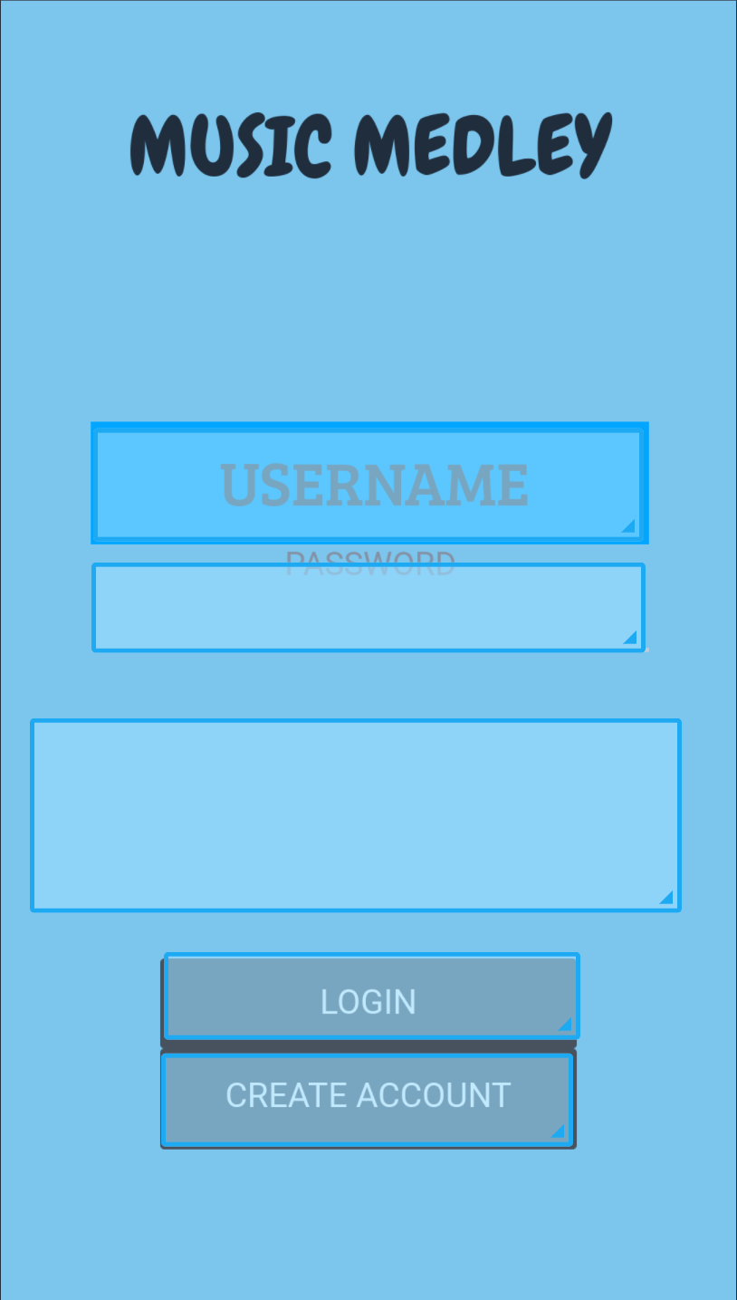

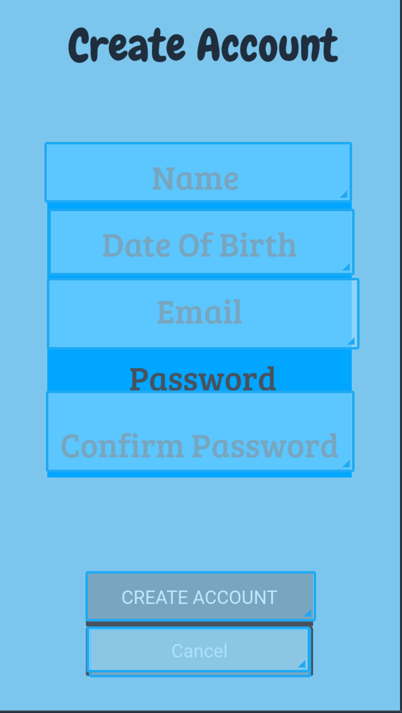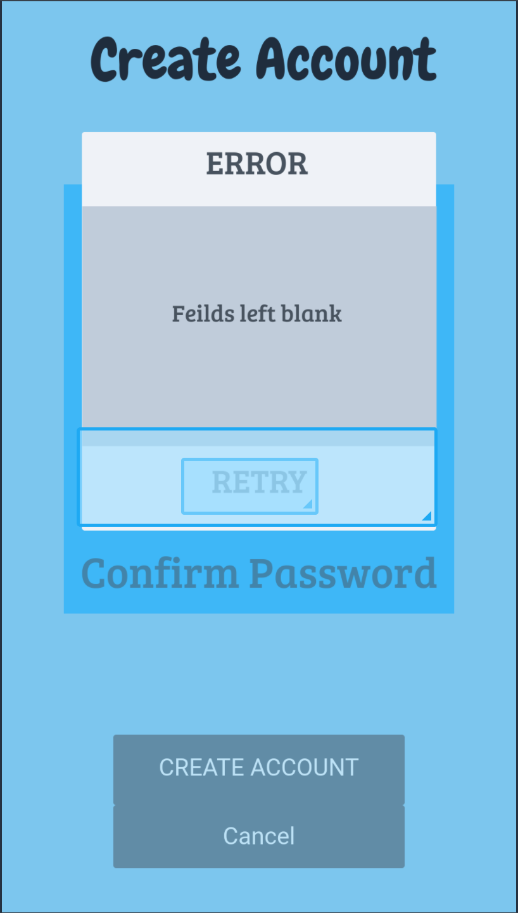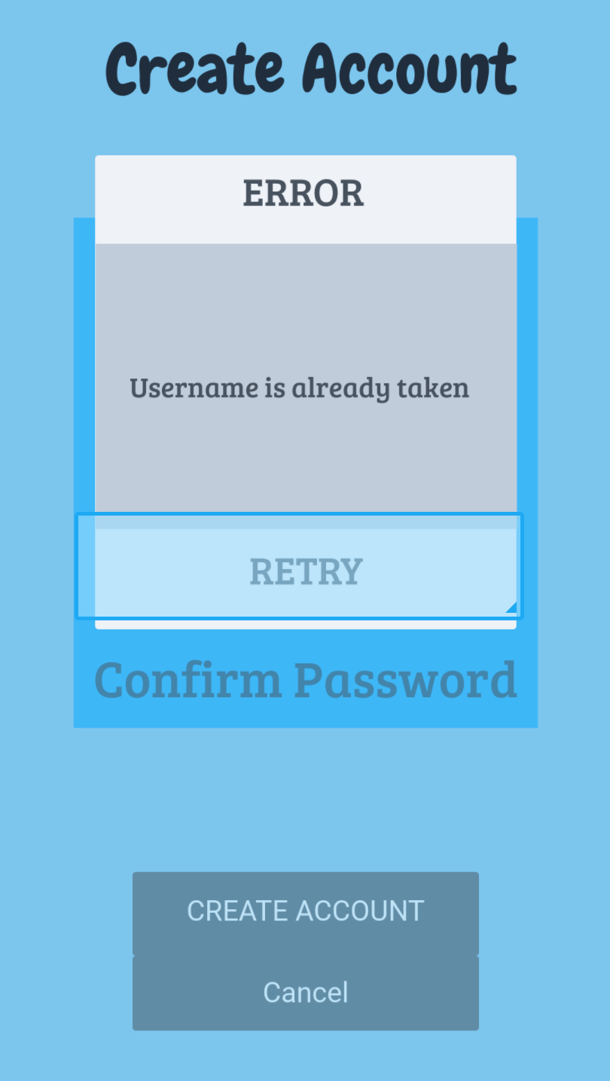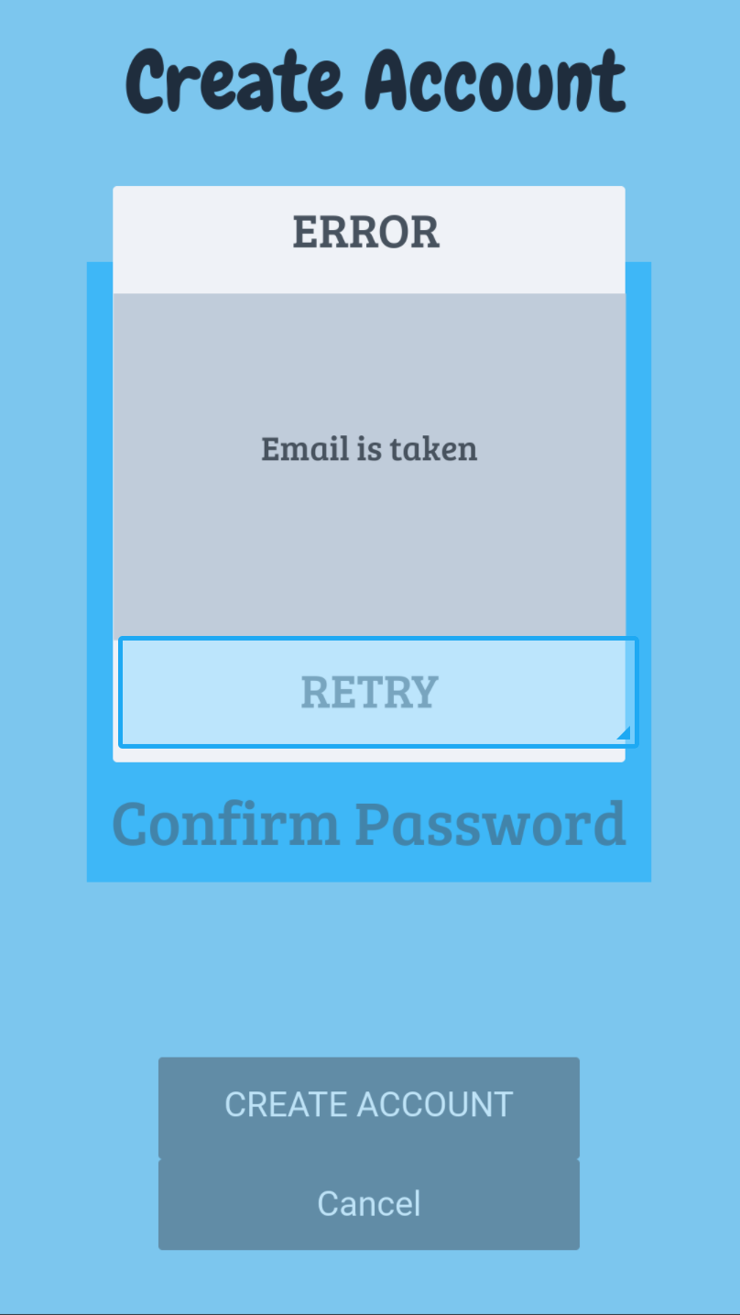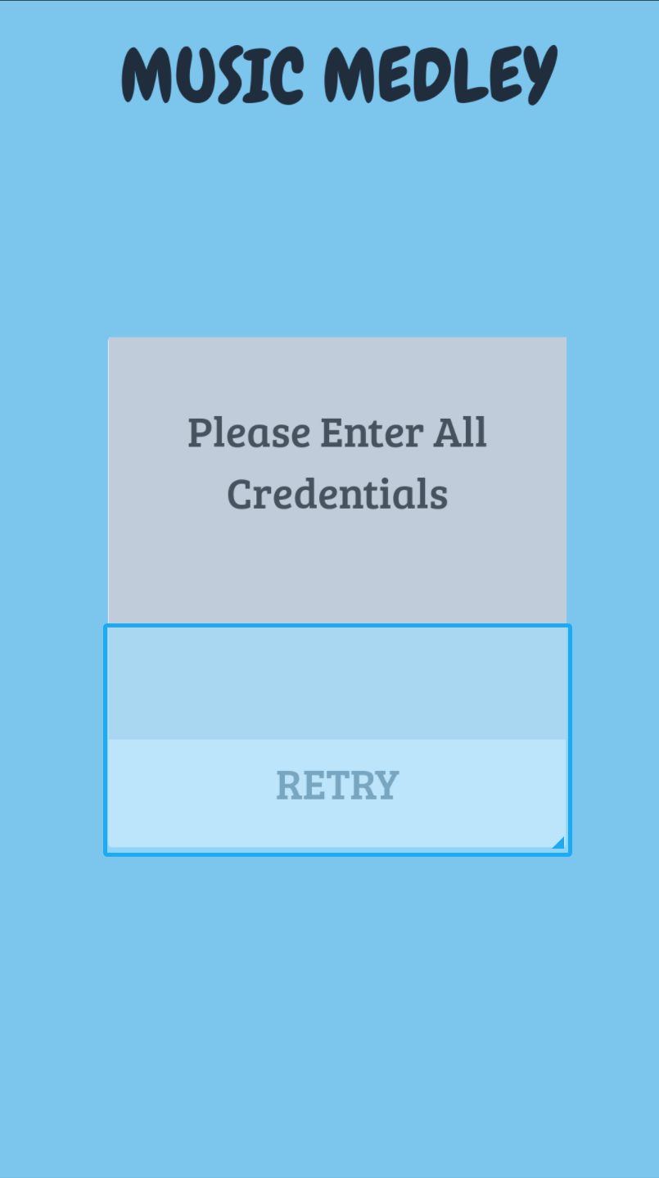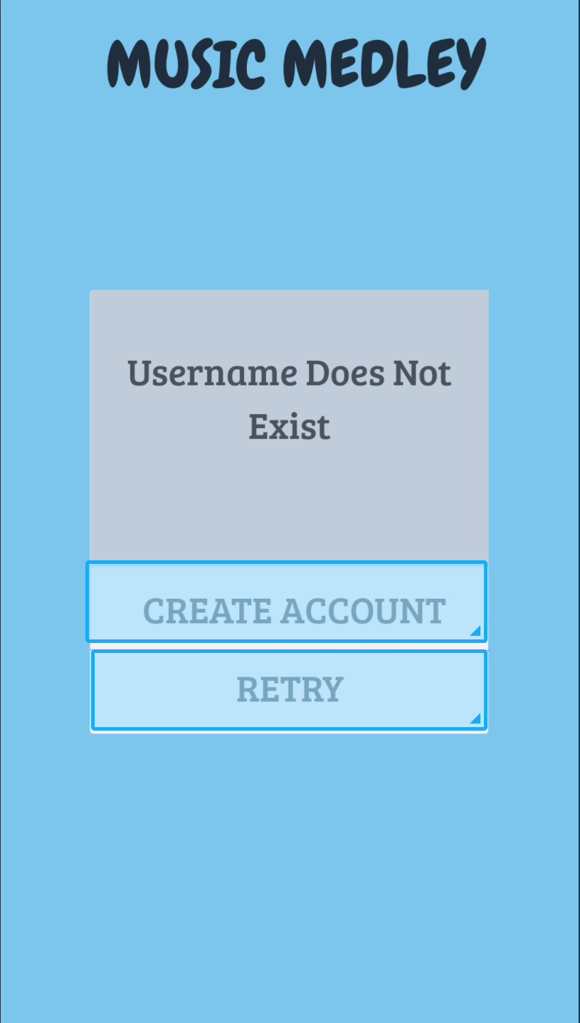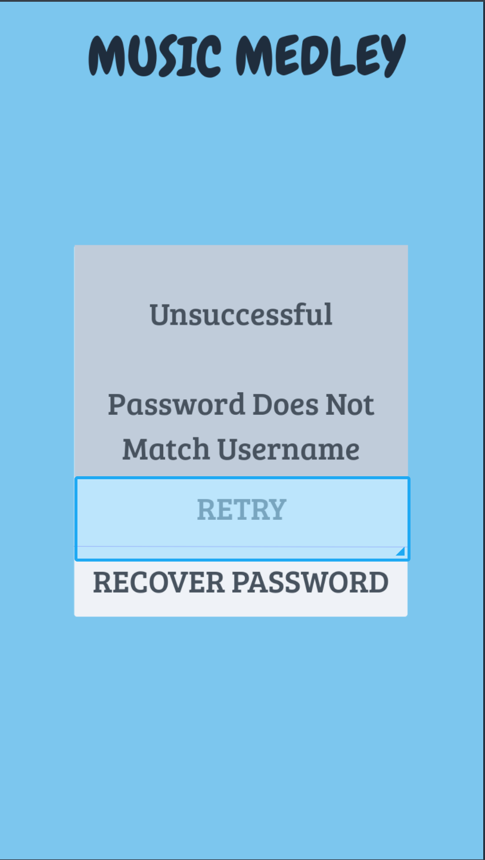

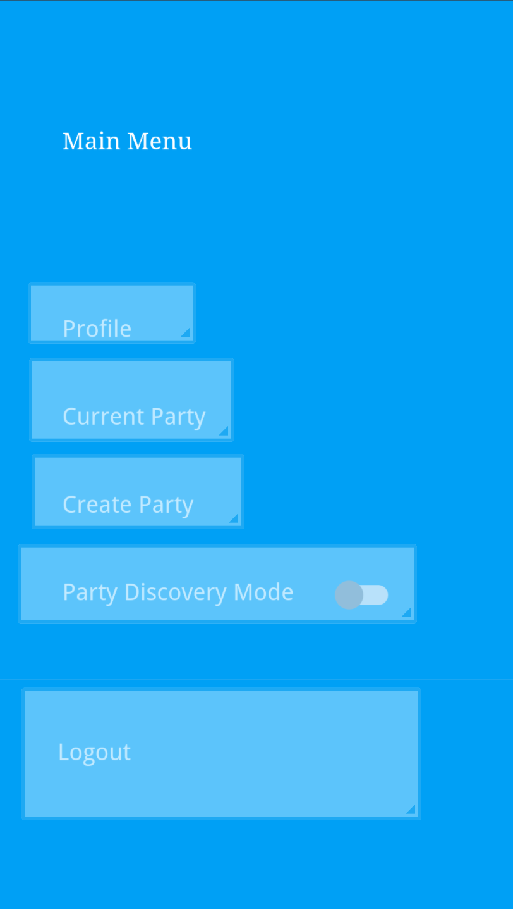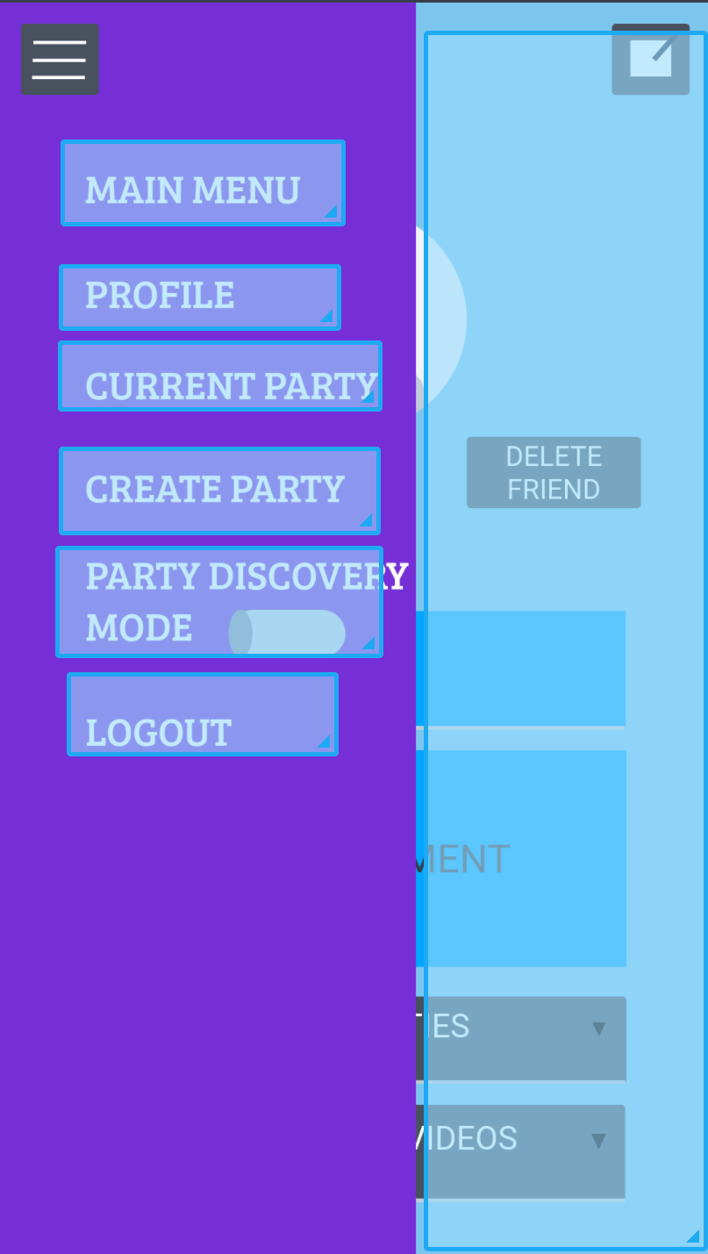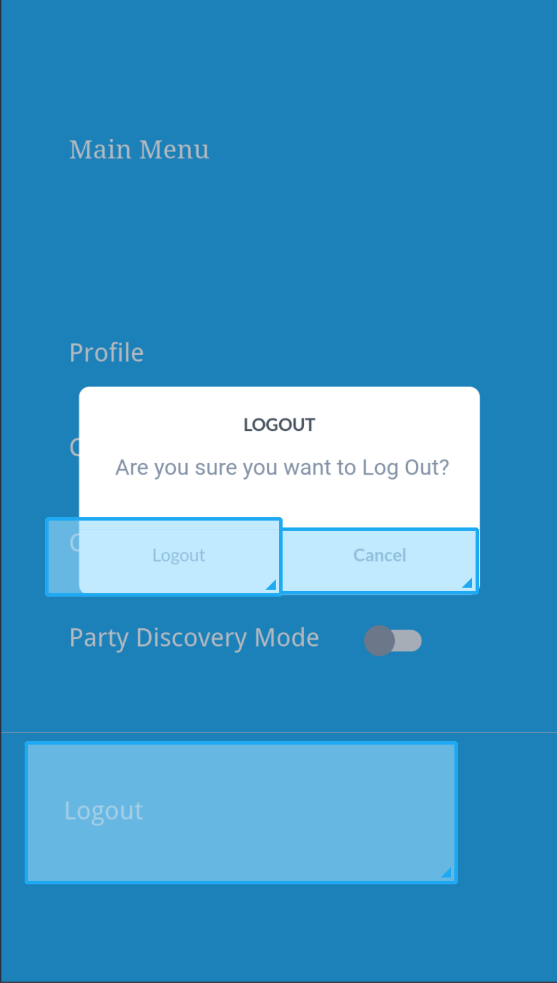

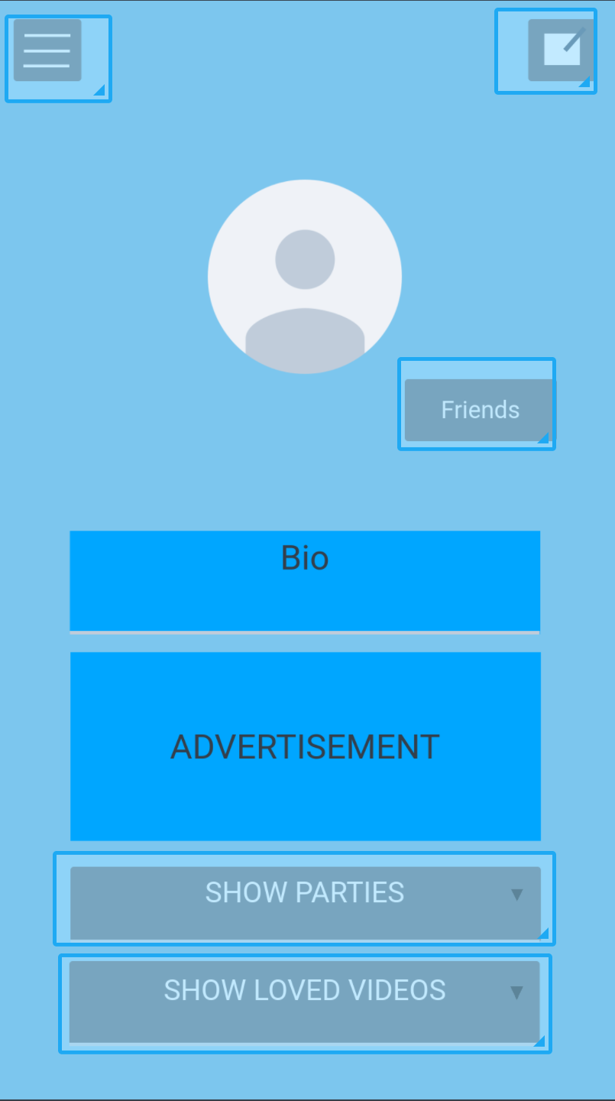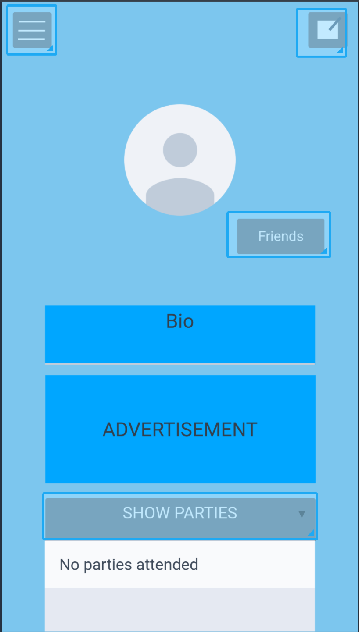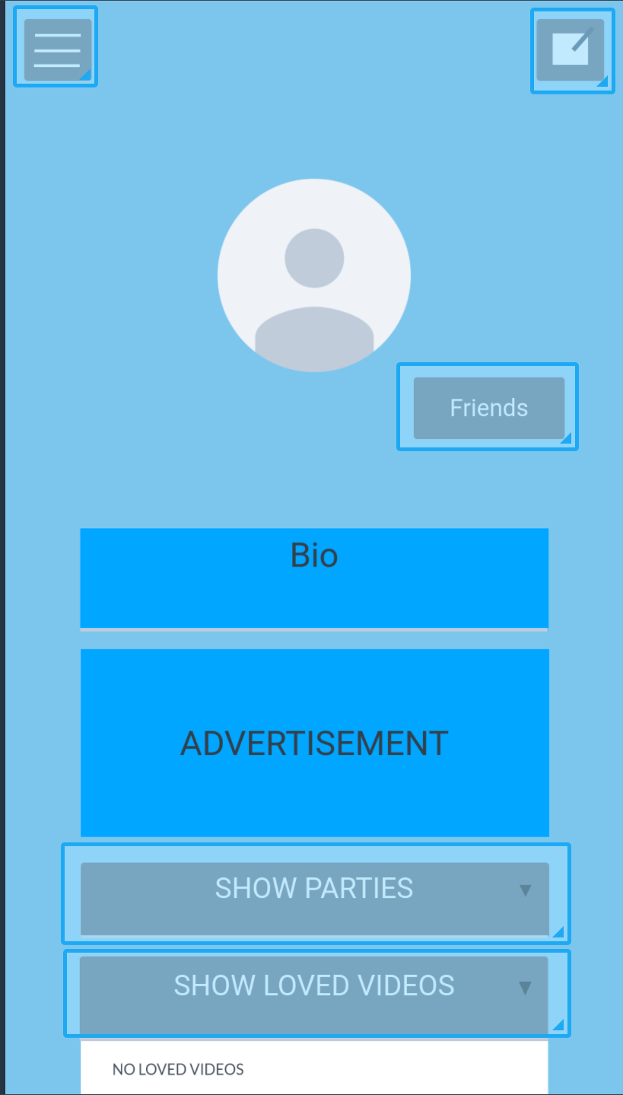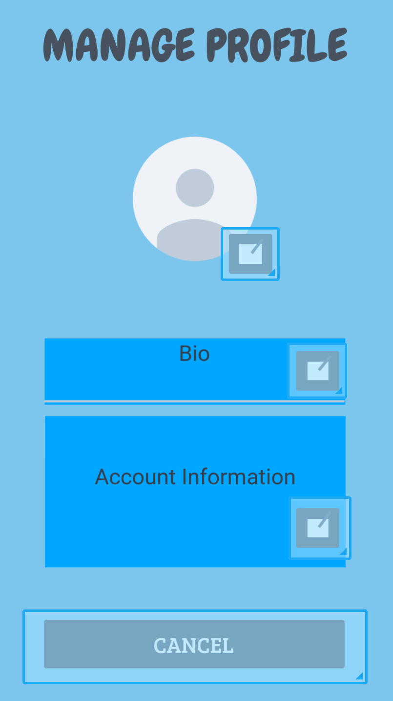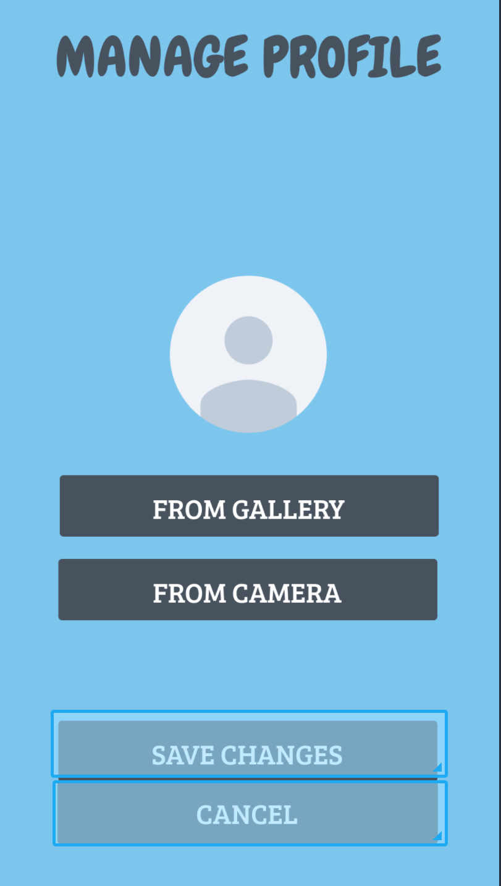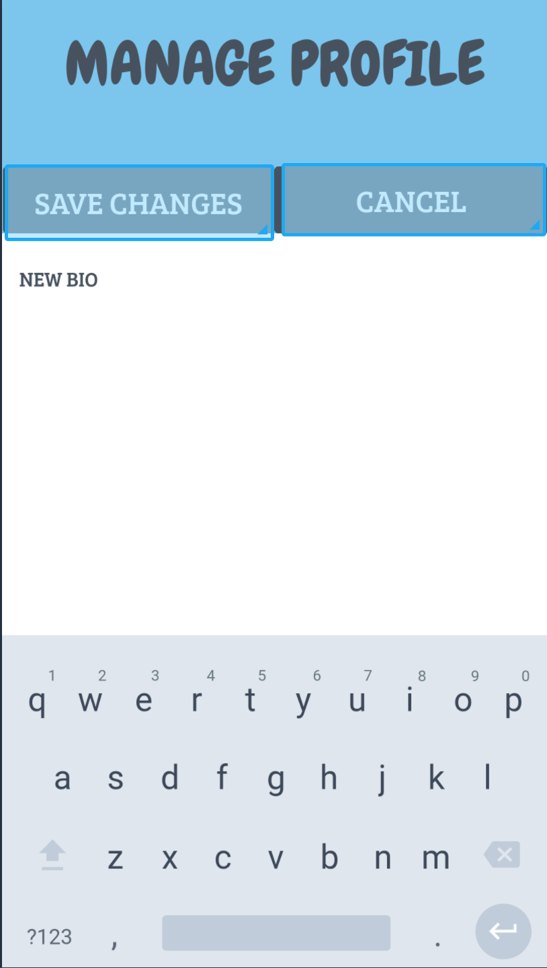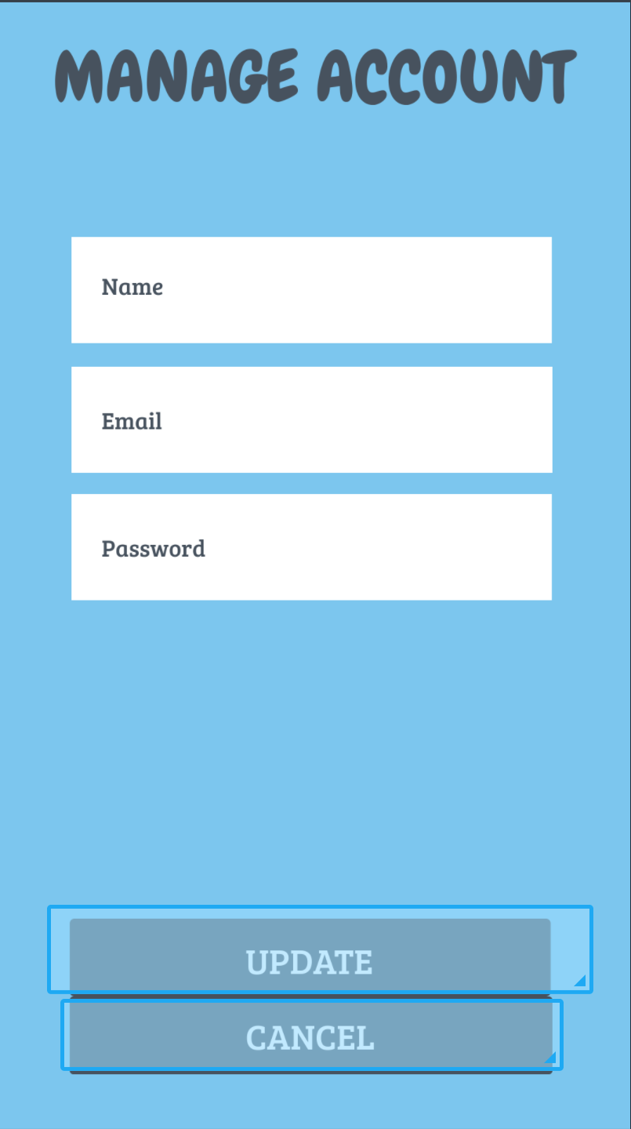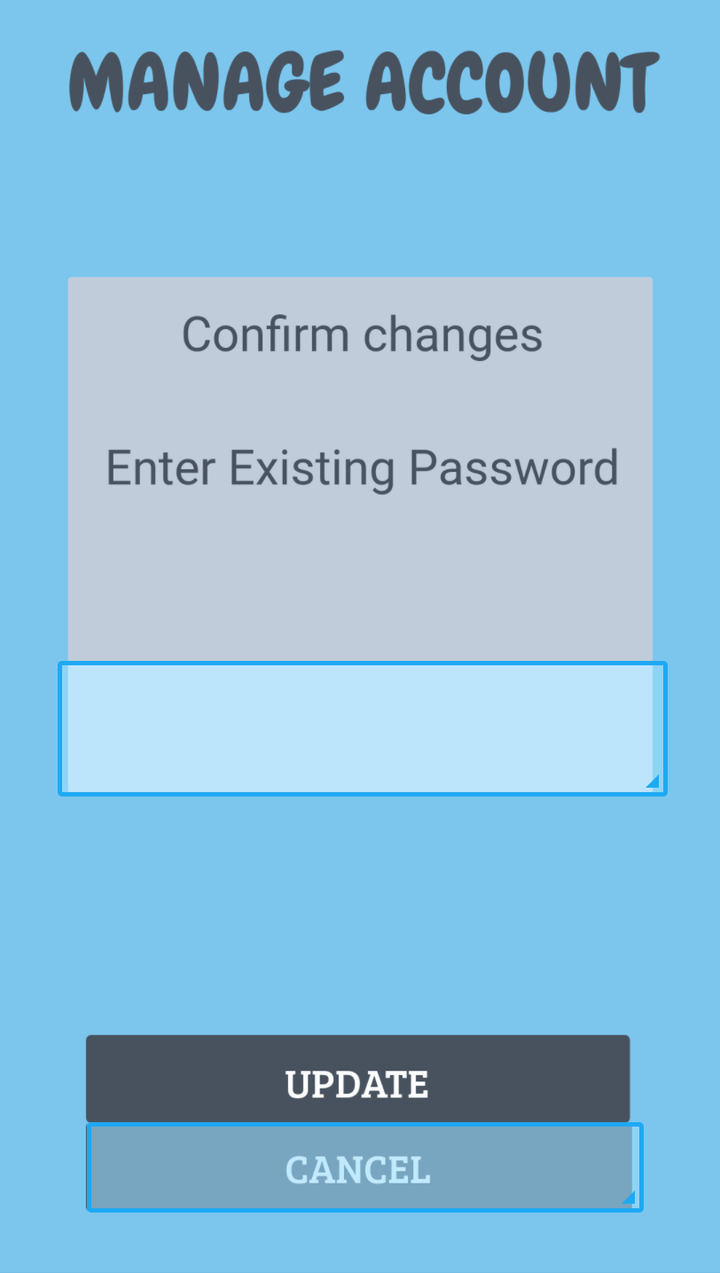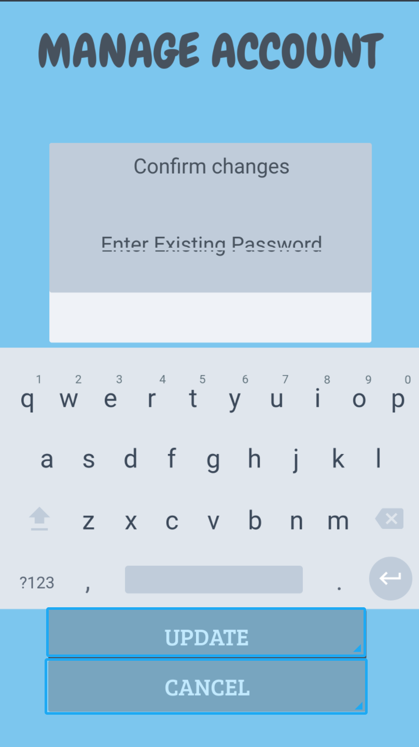

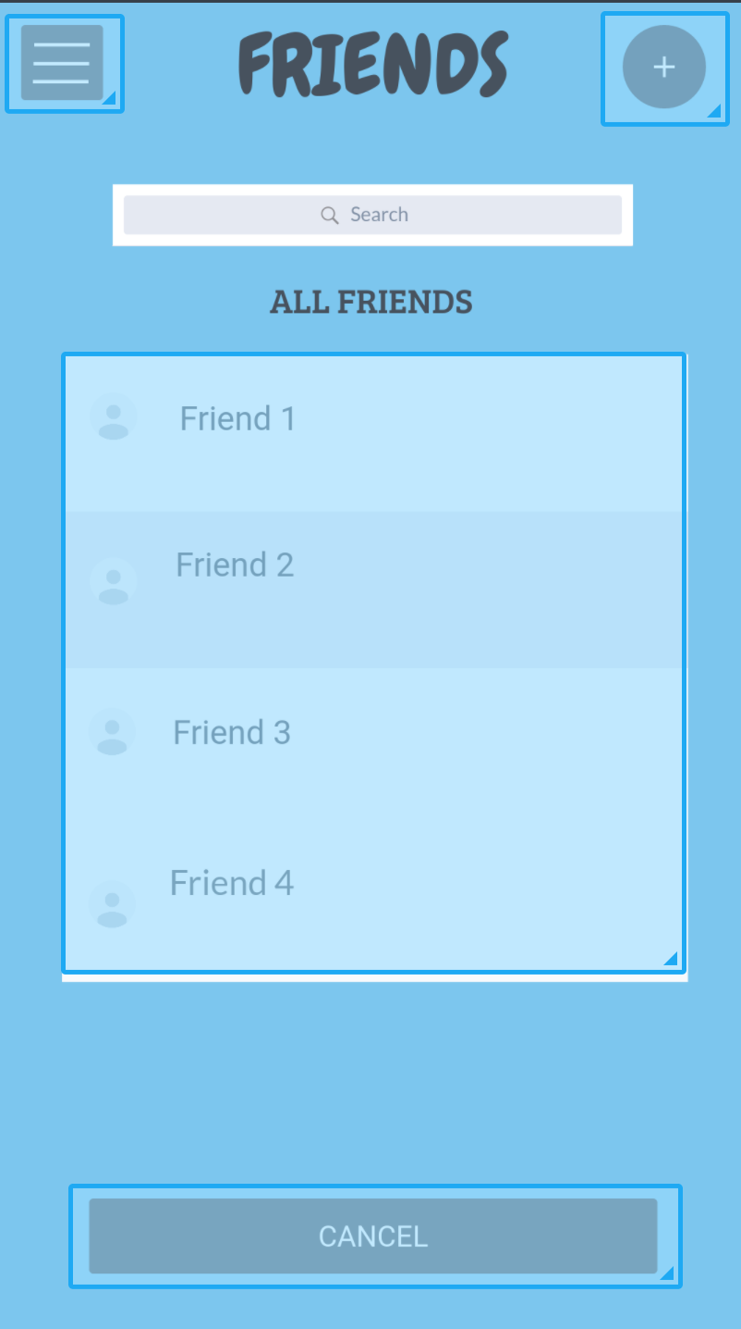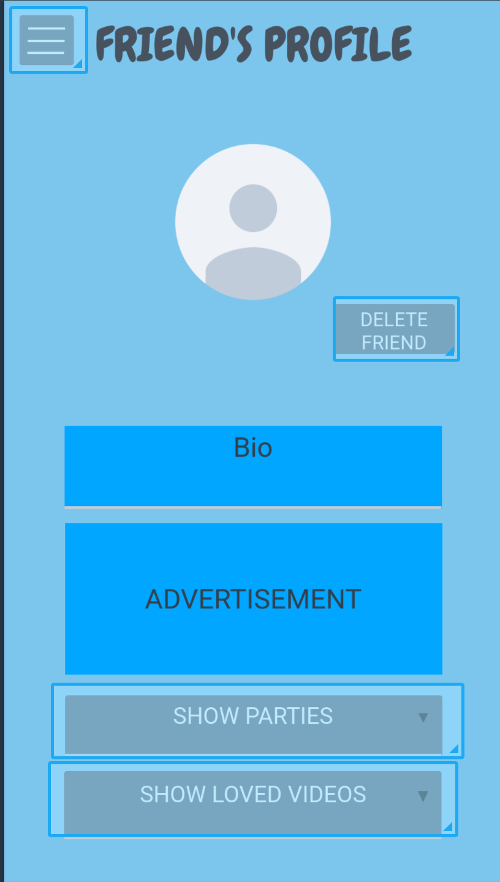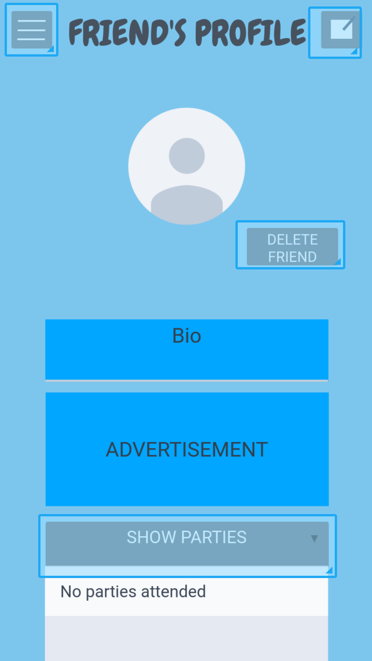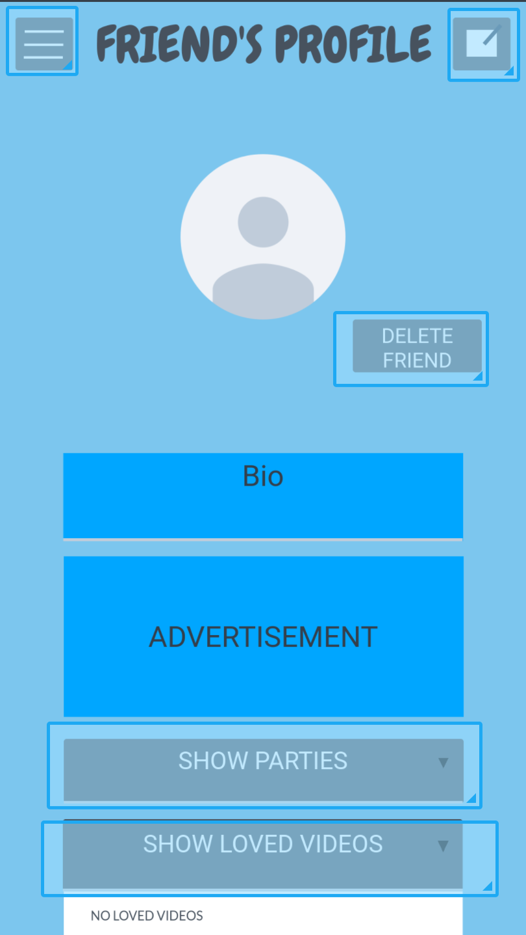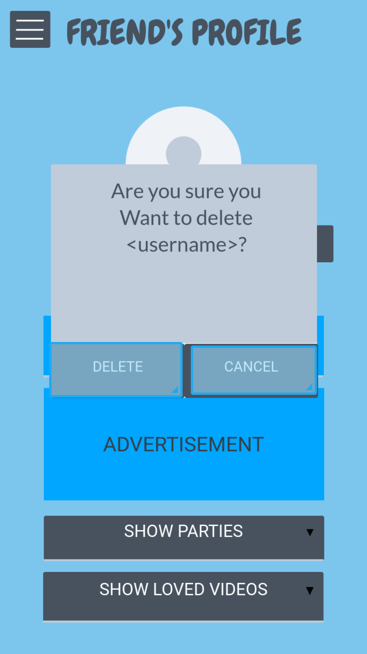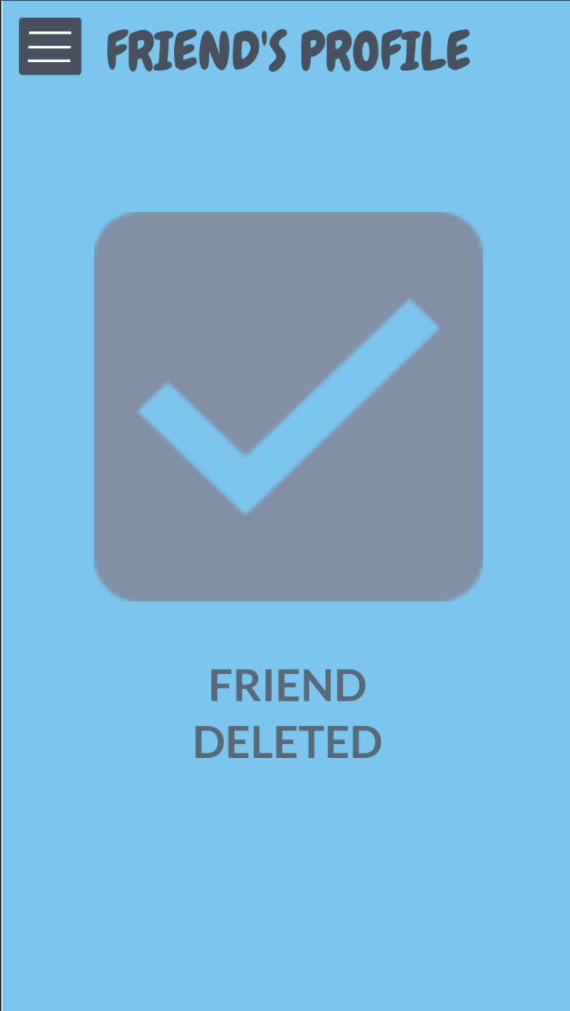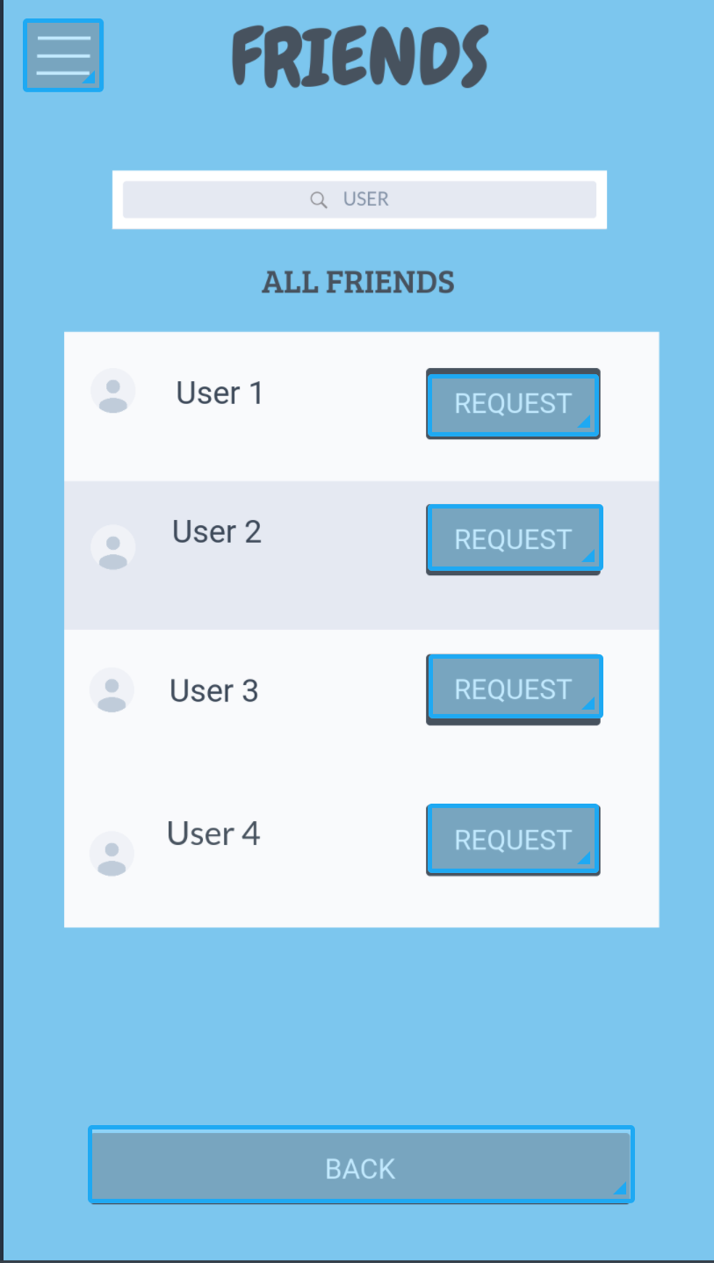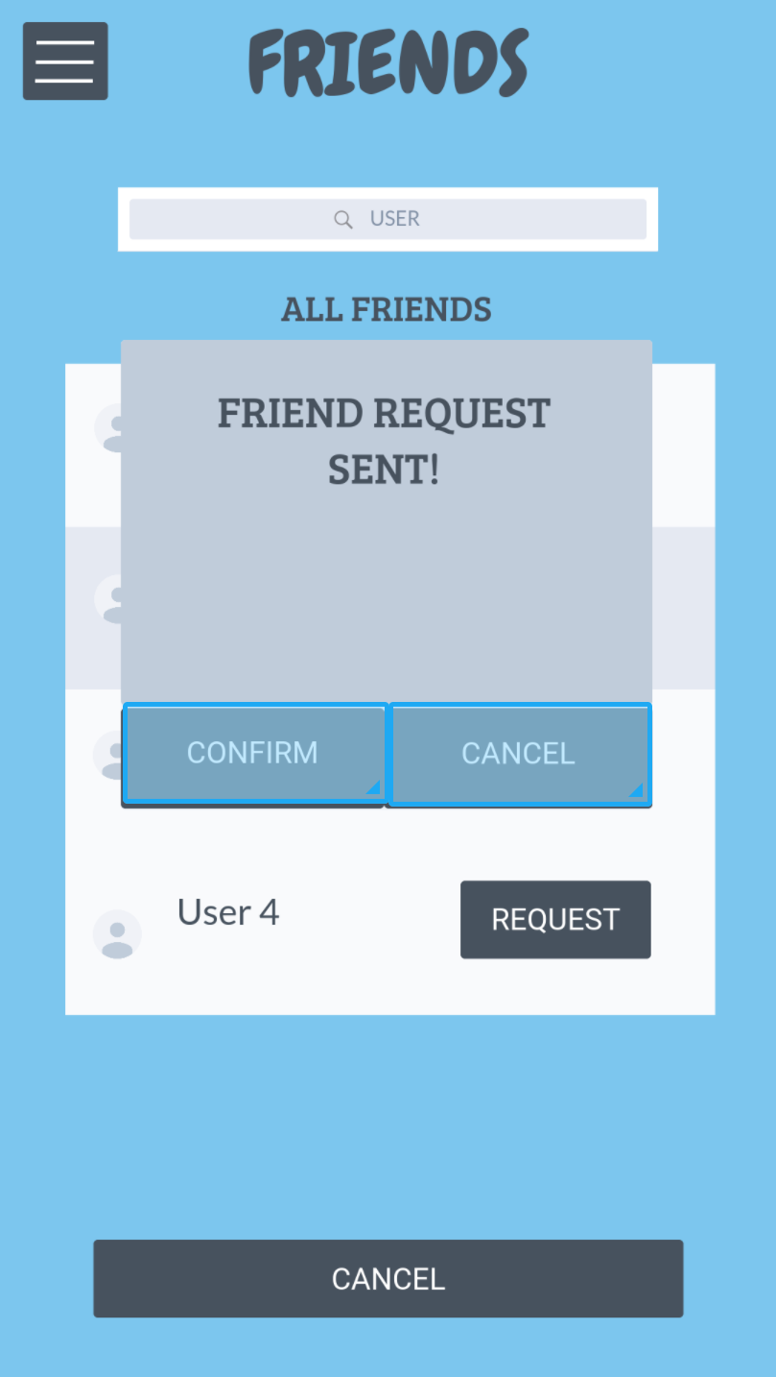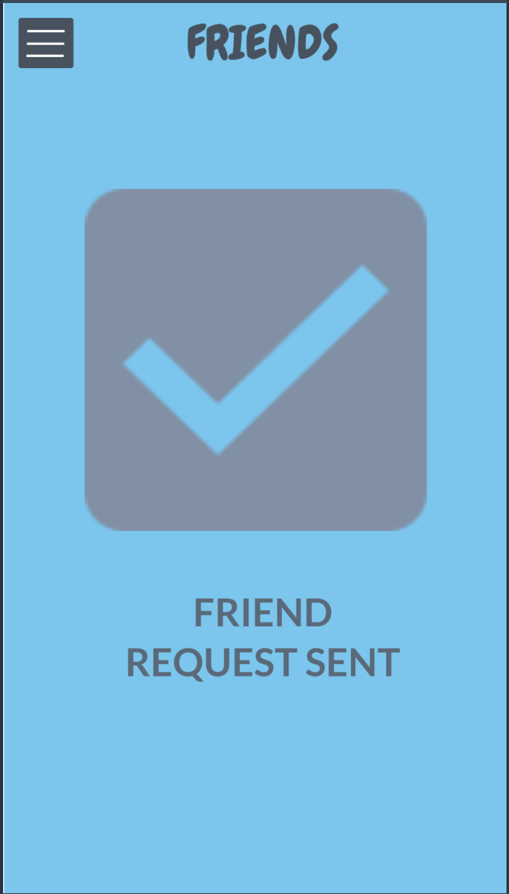

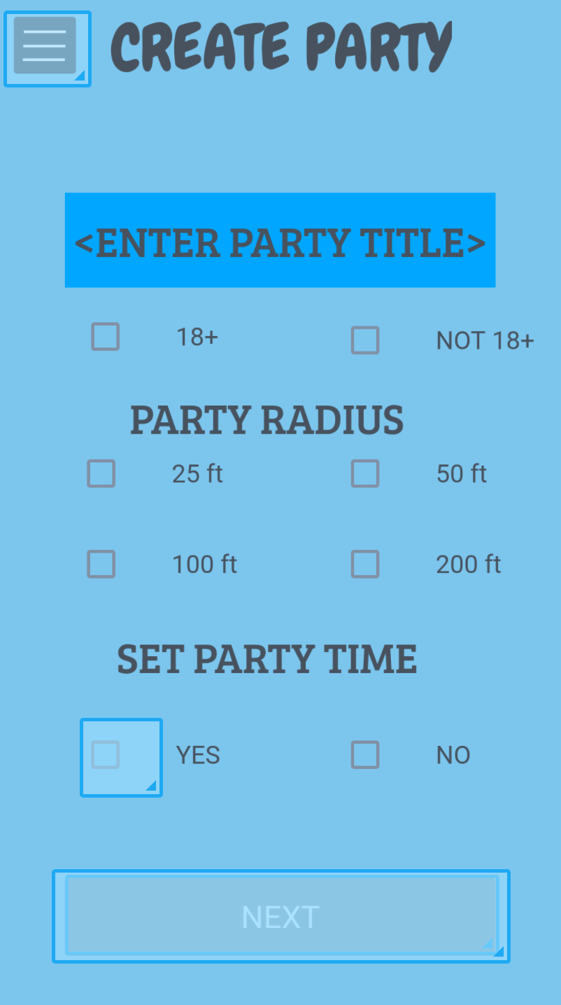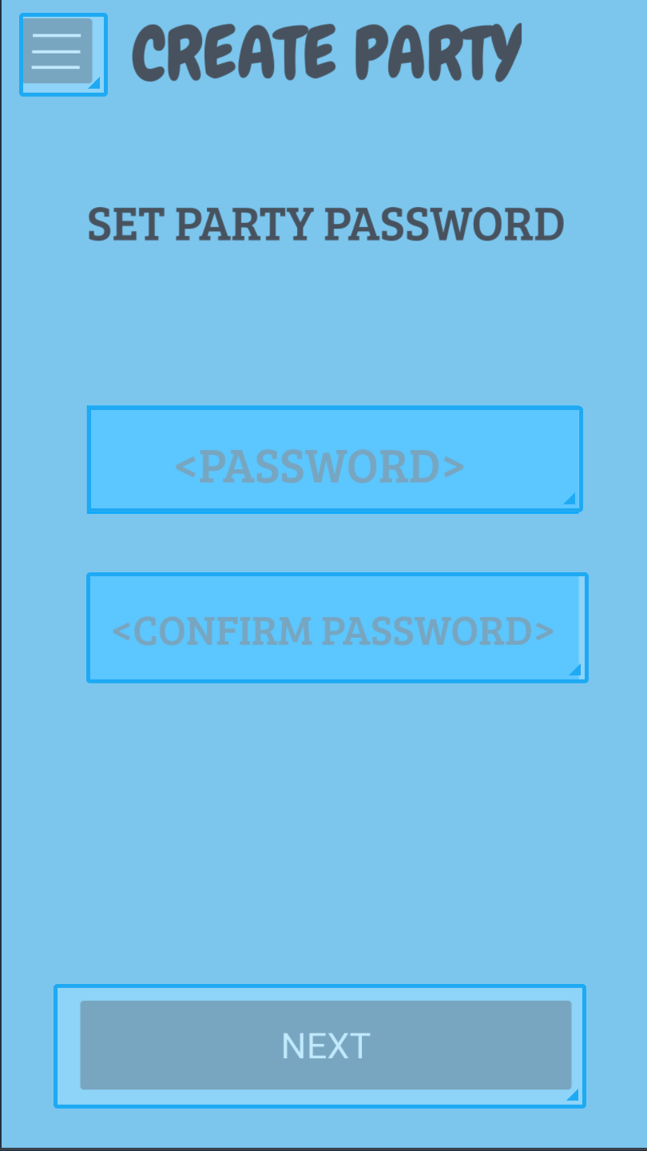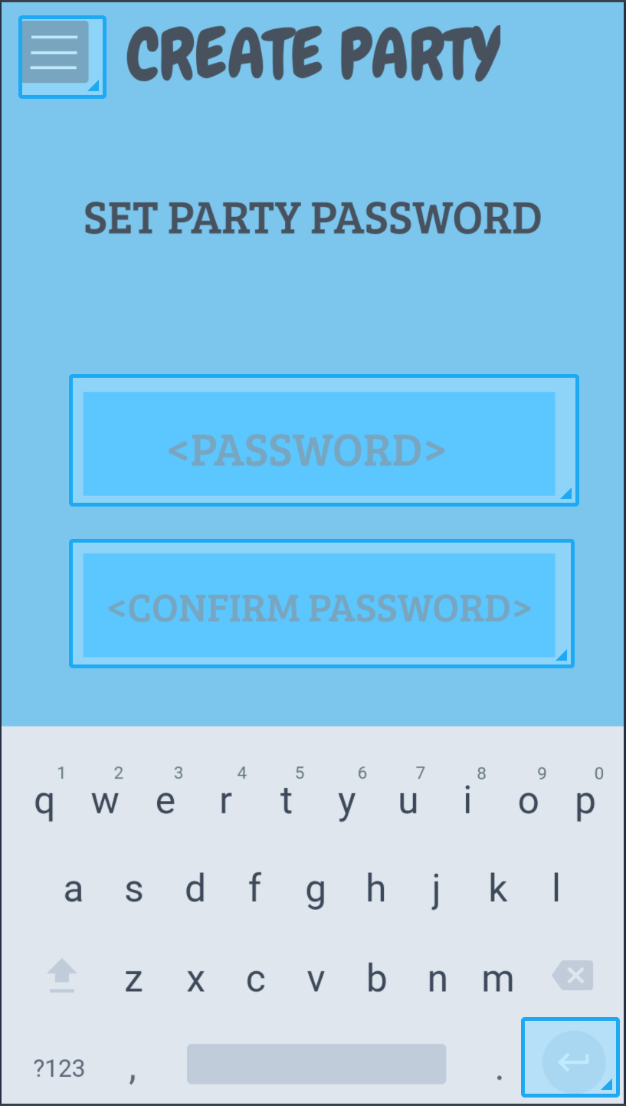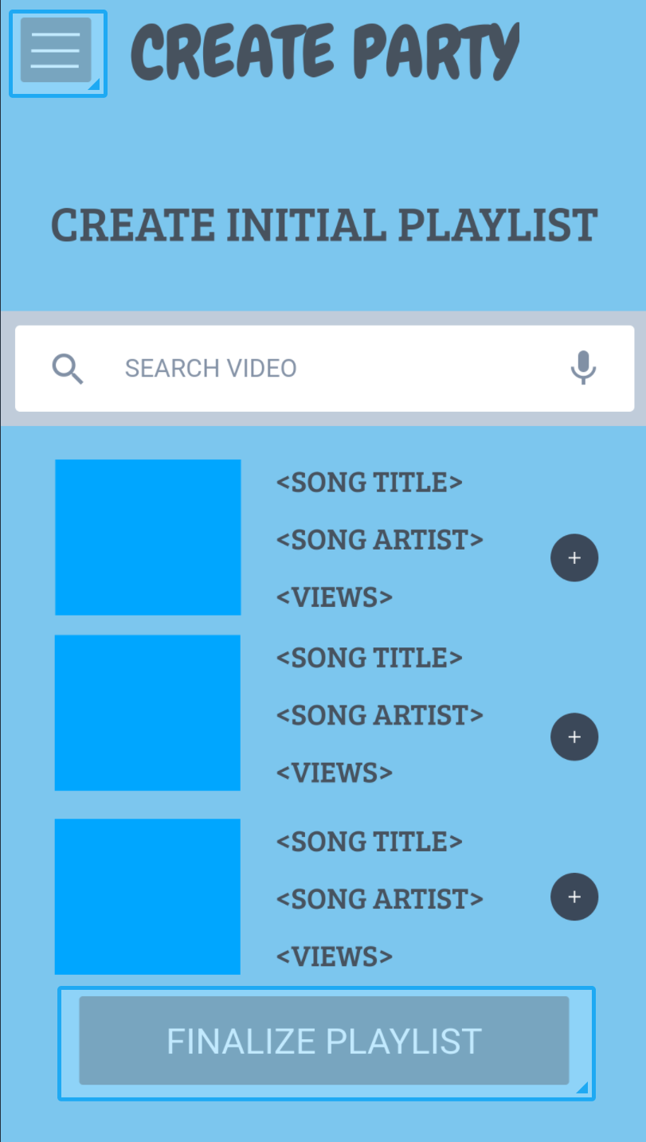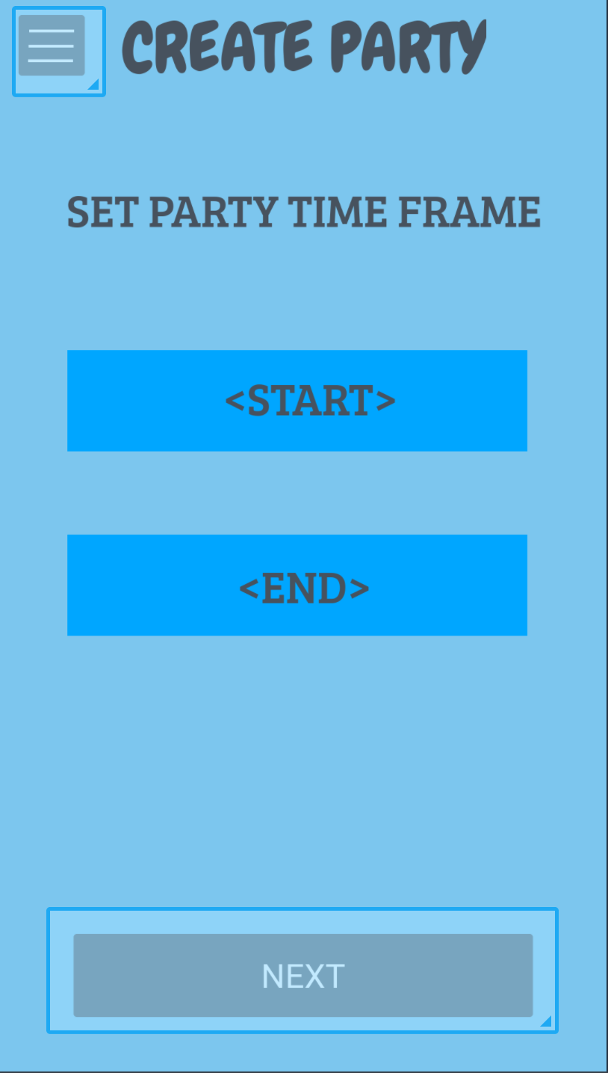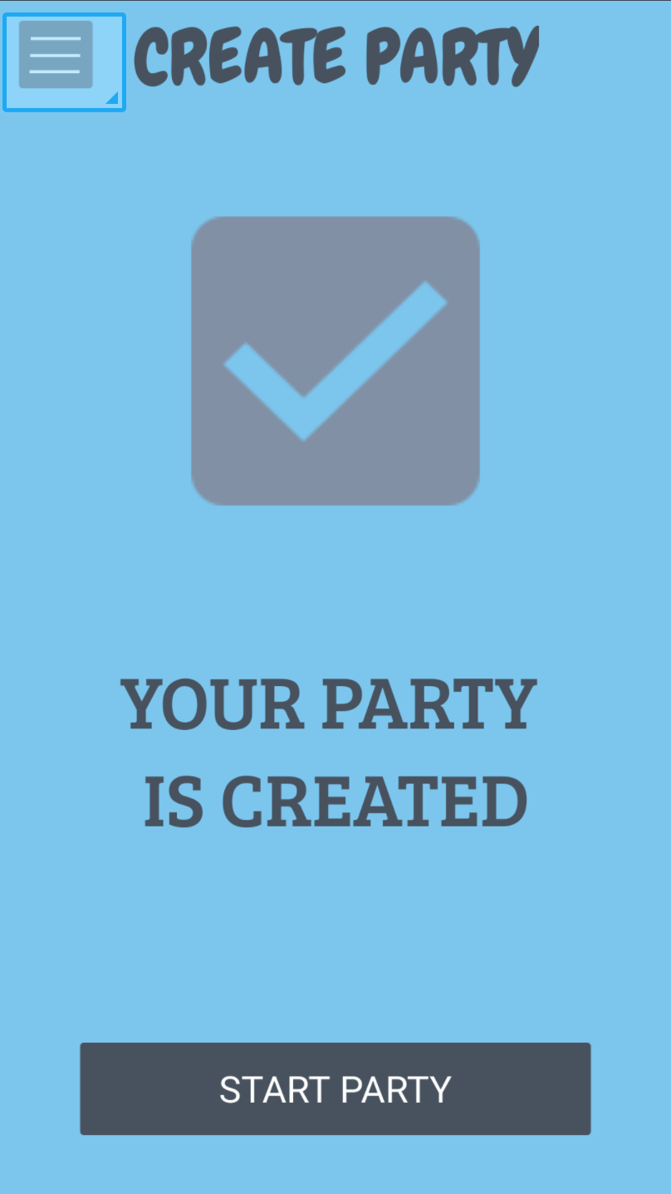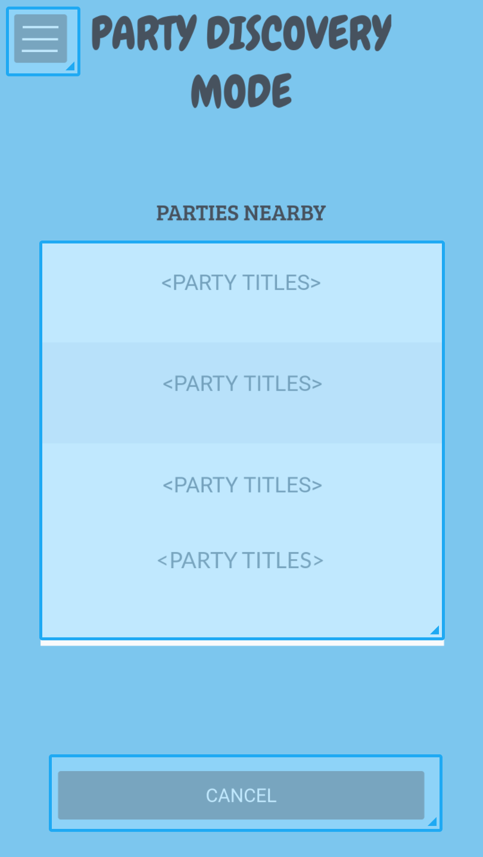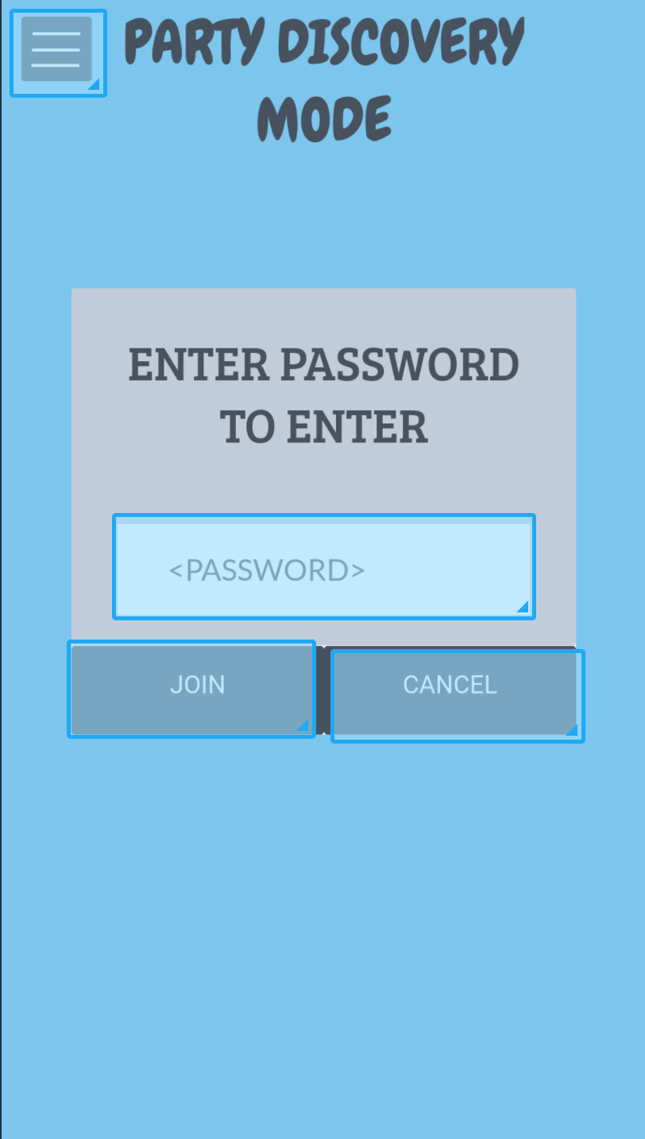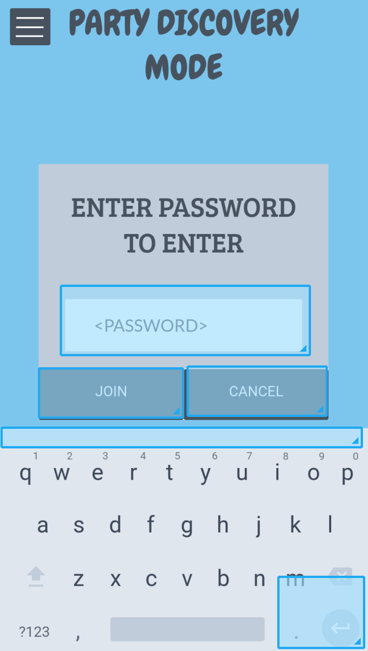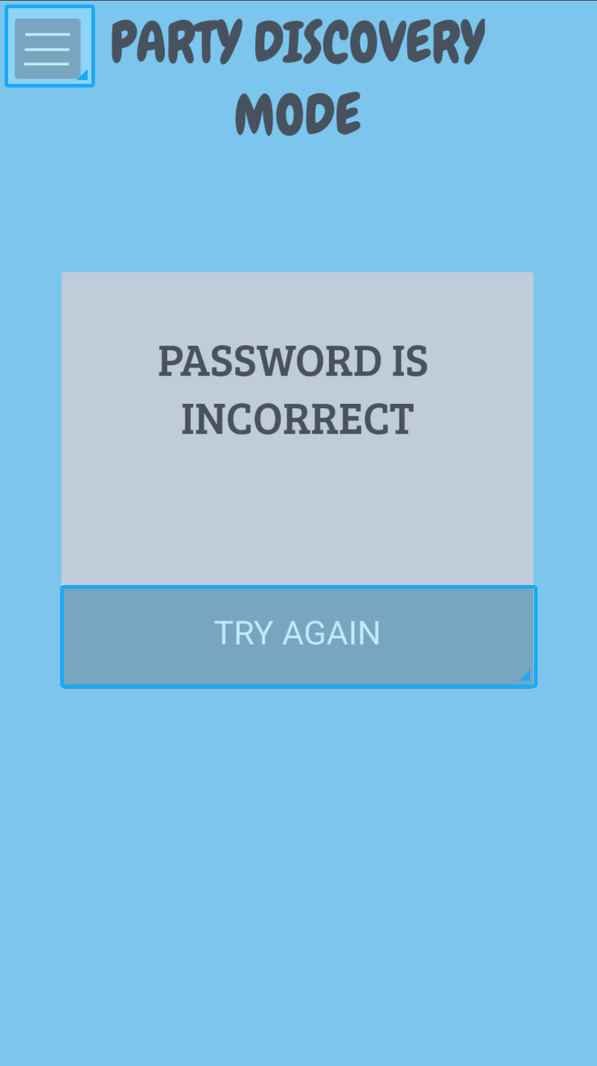

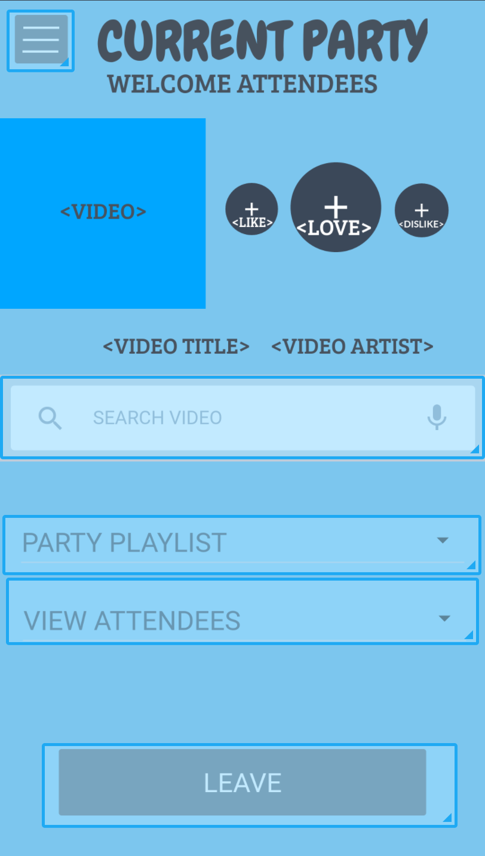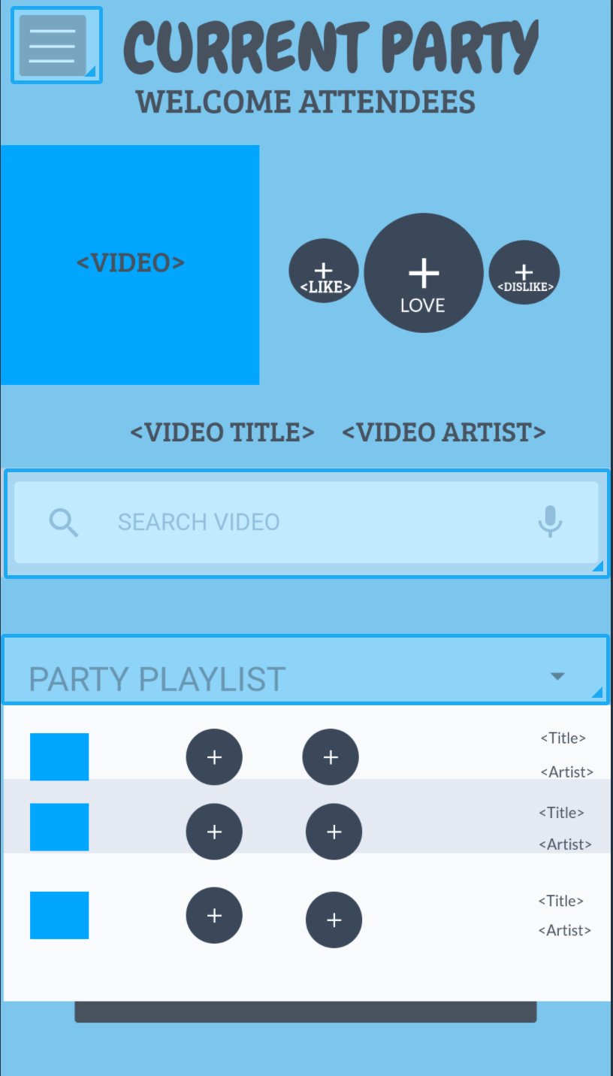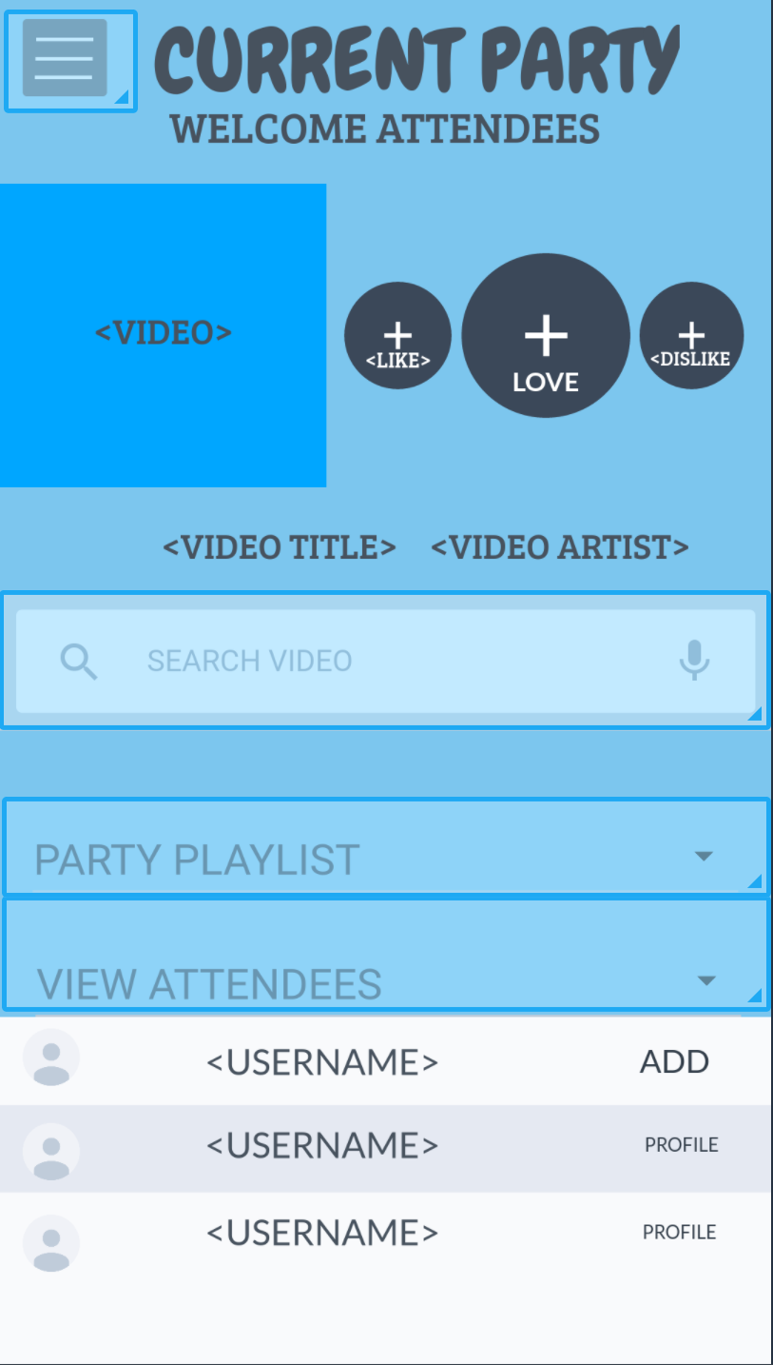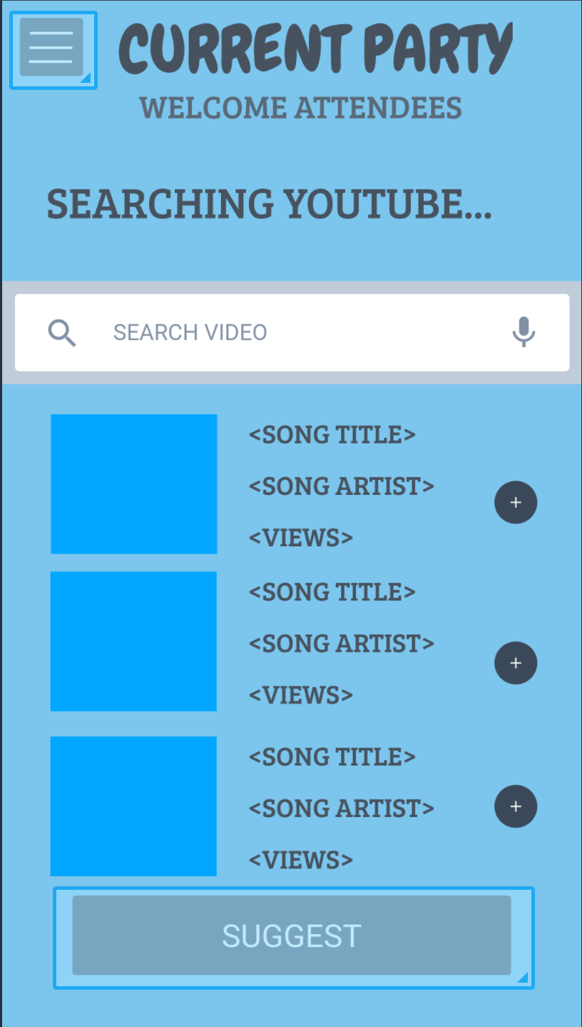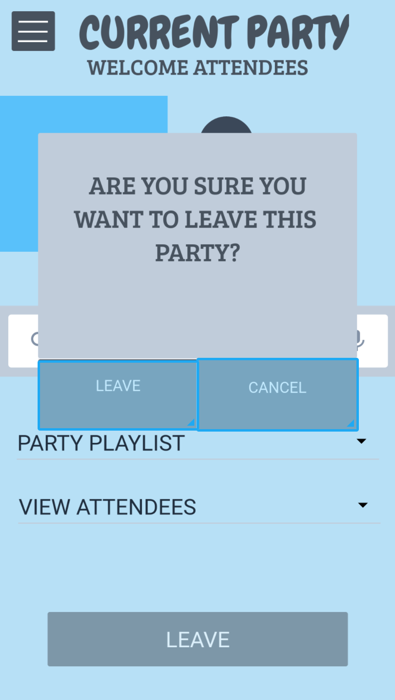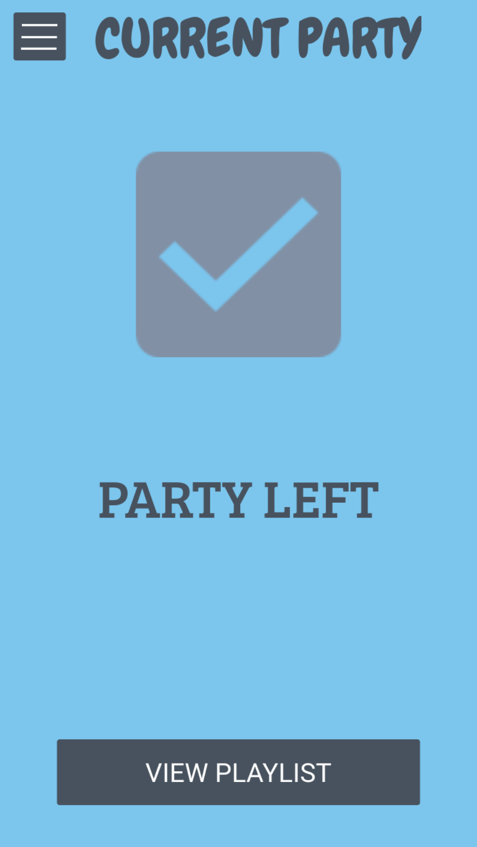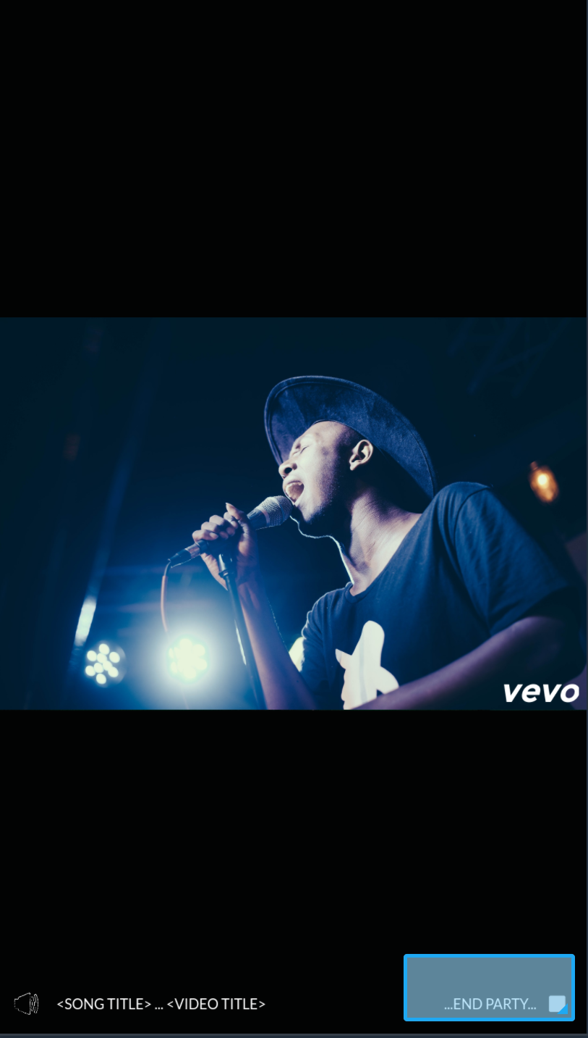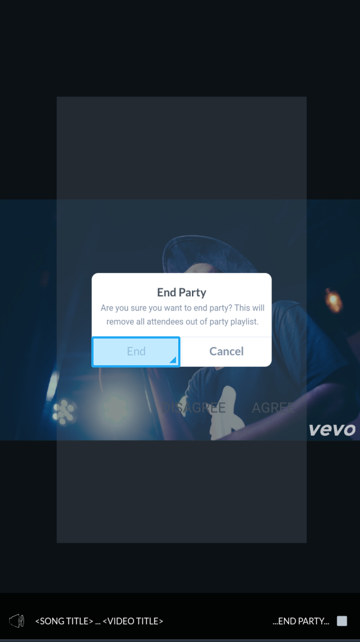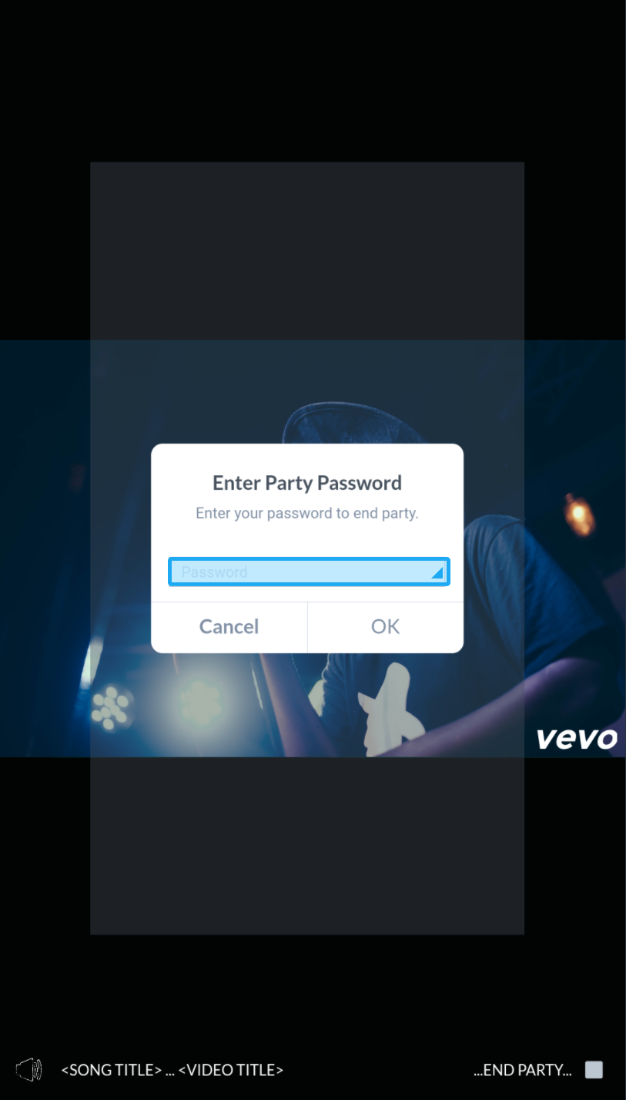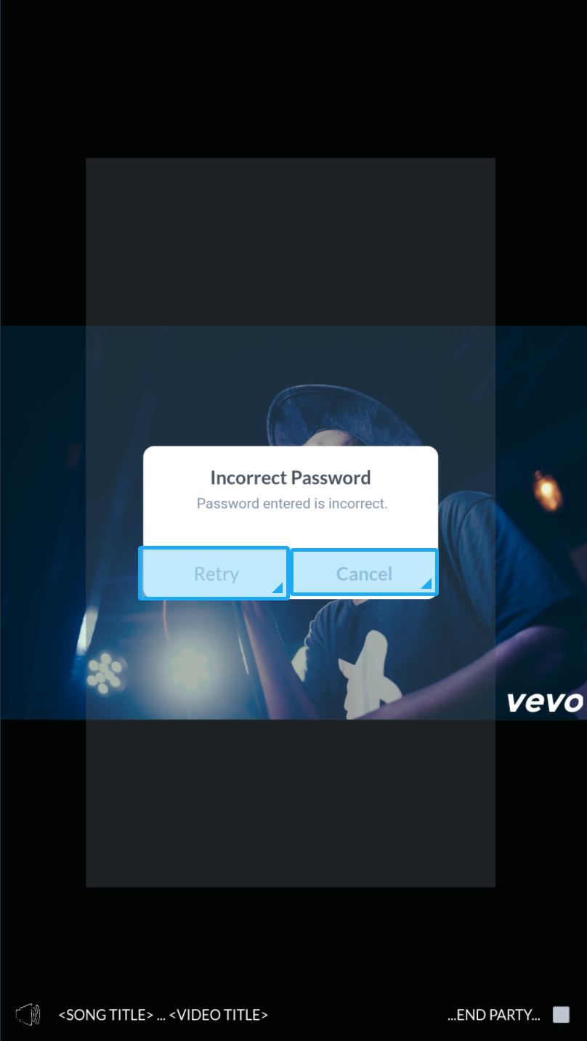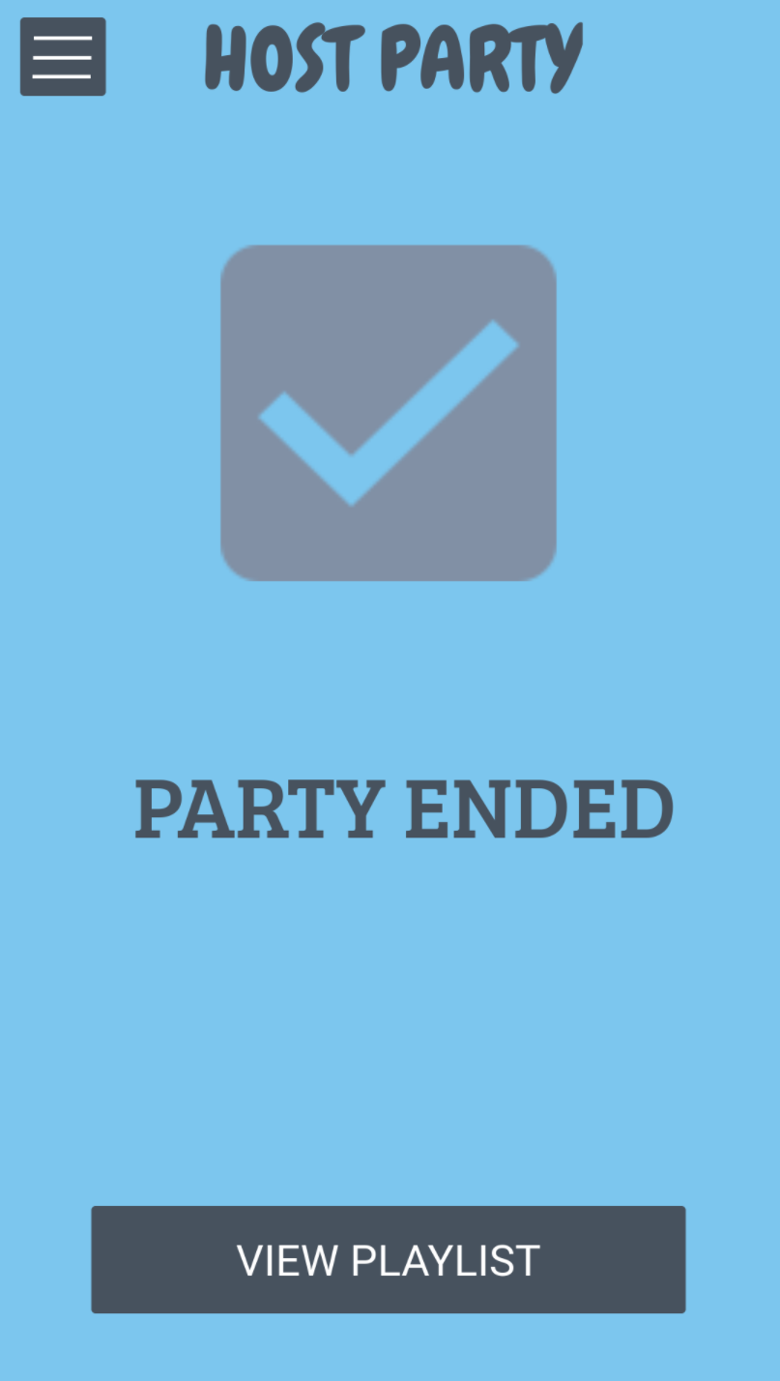

To view our complete prototype, click [here](https://marvelapp.com/28id7ja/screen/35708039).